**Multimodal WanderTales - AI Generated Travel Insights with GAN Synthetic Data**

✅ **Integrated image & synthetic data generation into Streamlit**  
✅ **Added Stable Diffusion for AI-generated images**  
✅ **Integrated GAN for synthetic image generation**  
✅ **Streamlit buttons for easy interaction**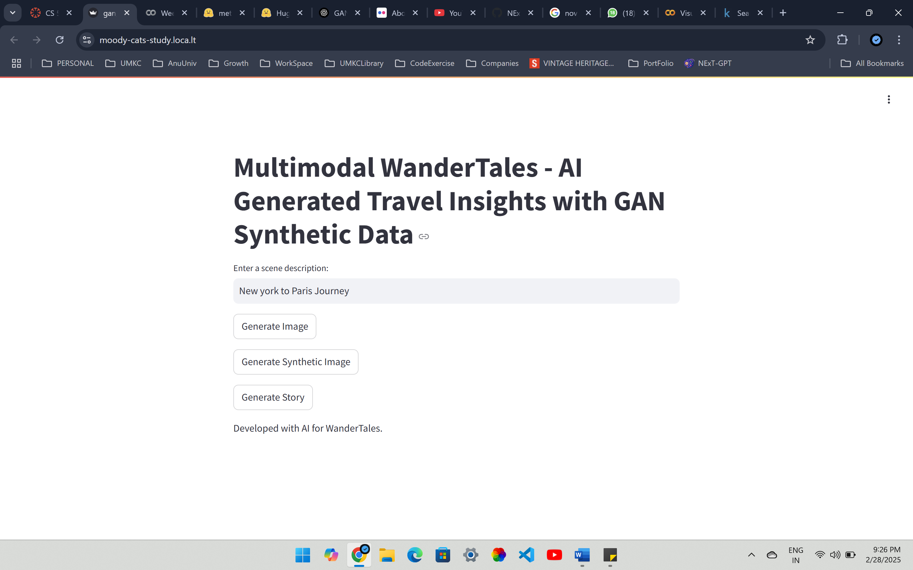

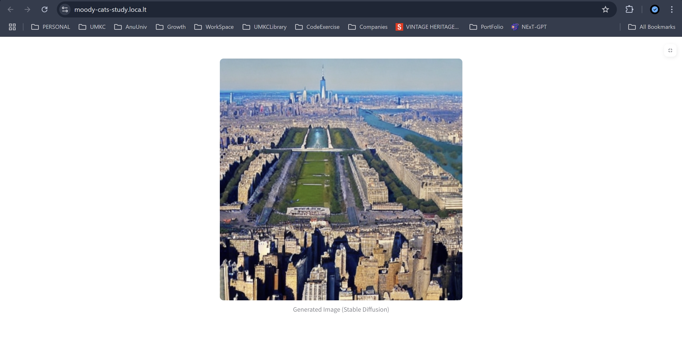

Generating Synthetic Image using GAN...

